Lab – Module 2

Shaun Pritchard

Rasmussen College

CDA3315C

Alan Dennis

July,15 2020

Lab – Module 2

In this lab I updated the interface to pull out the active database tables and display them in the web application. I also added a new column to display the current database table that all the submissions are stored in, and I added a delete function to unregister a user. See screenshots below in *Lab Module 2 section.*

**Lab- Module 1:**

1. **Logged in to student cloud portal system.**

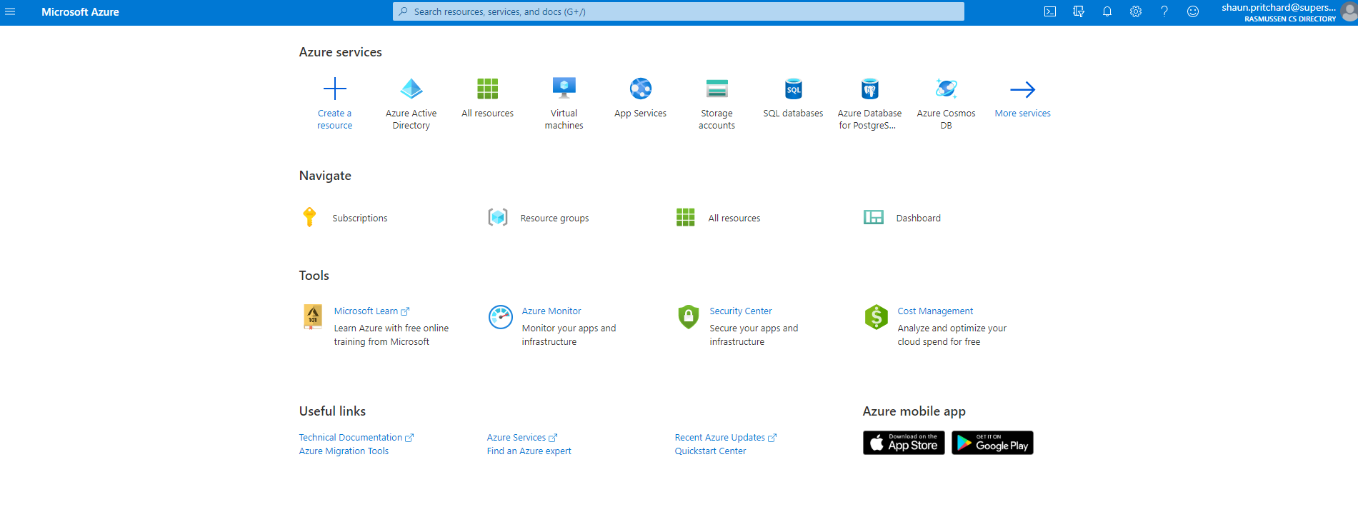

1. **Created a new Web App + MySQL service on Azure.**

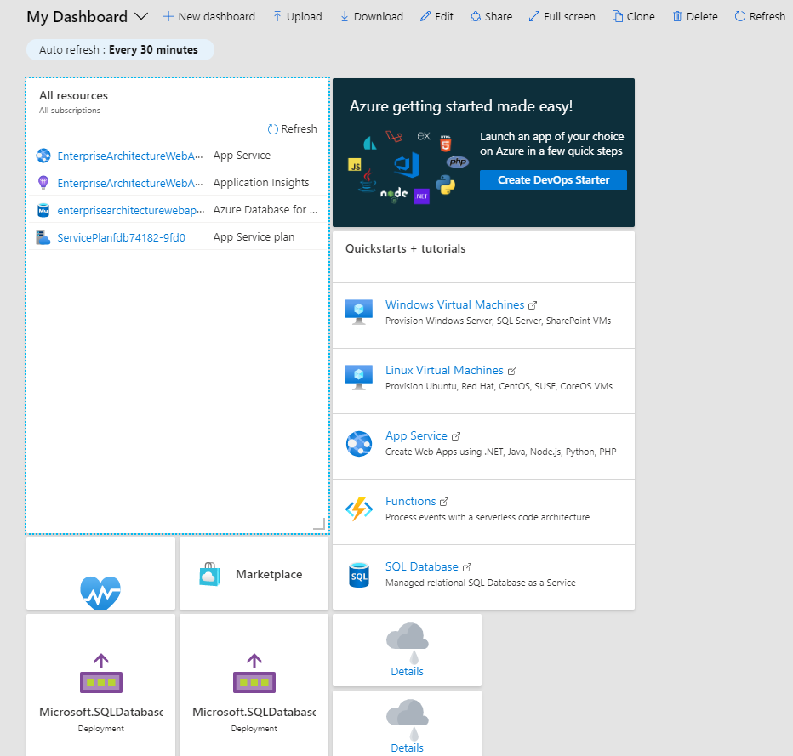

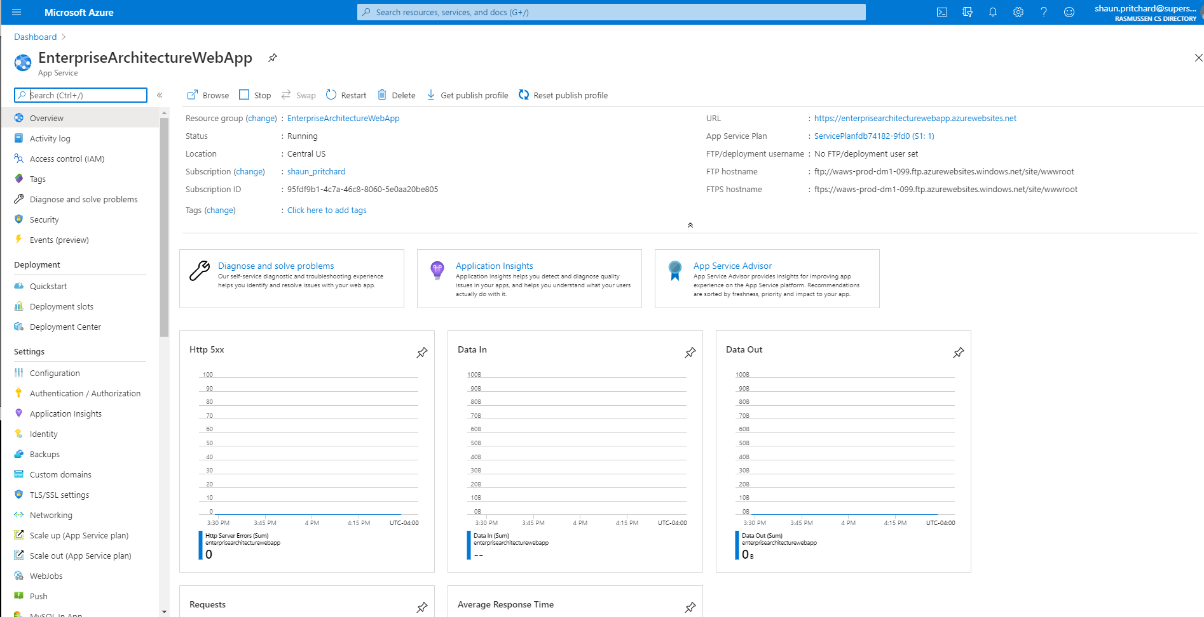

1. **Create a new MySQL database service.**

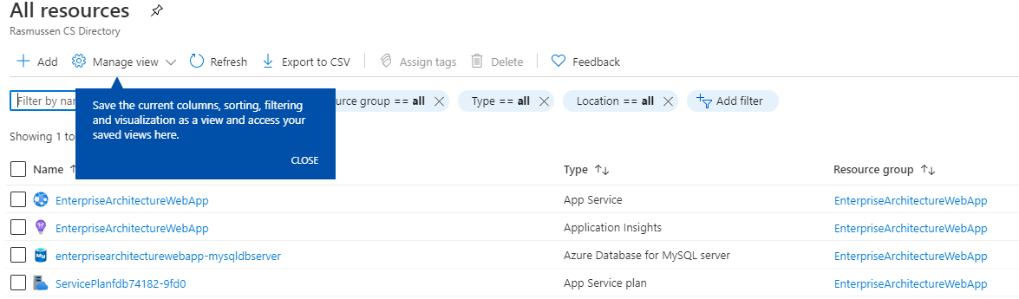

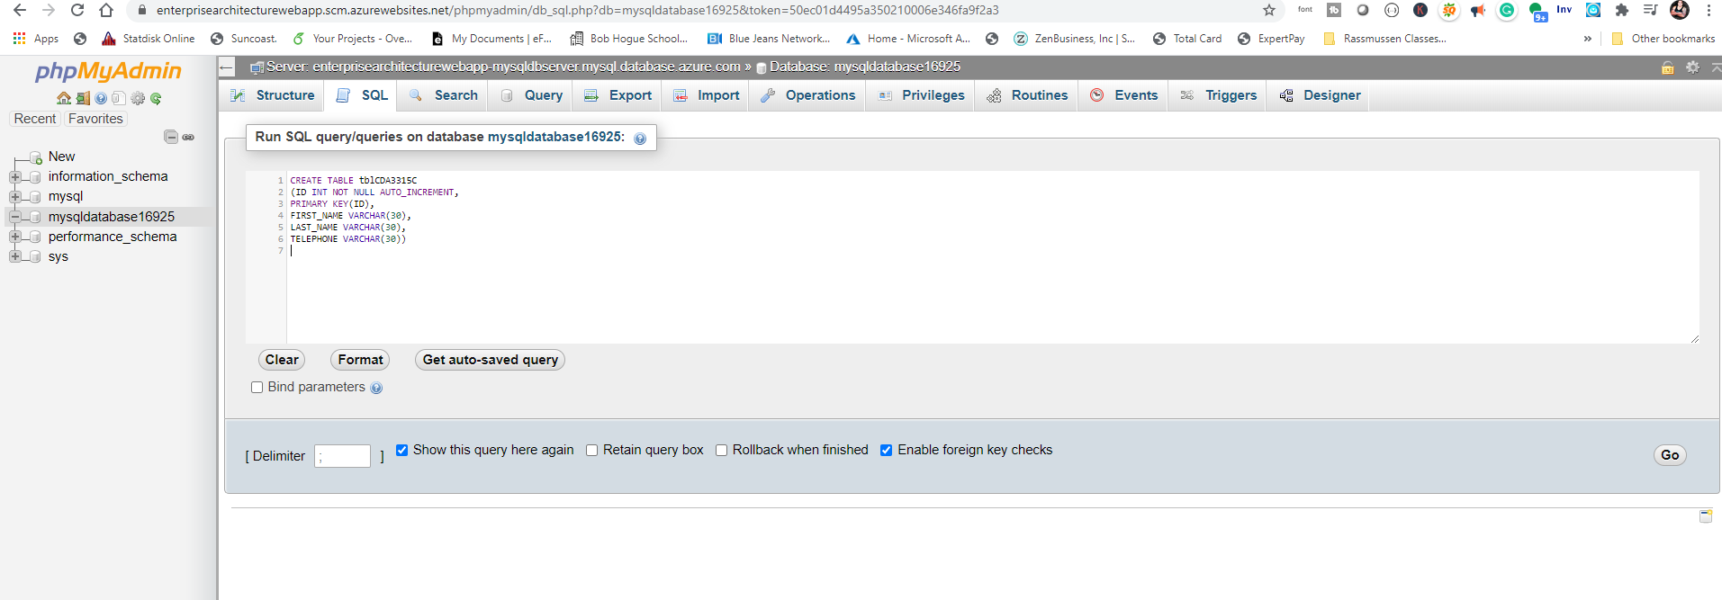

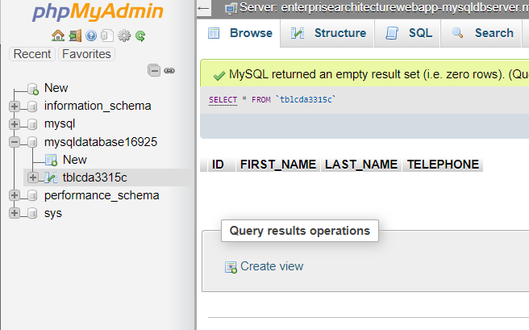

1. **Create a new Web App service connection string.**

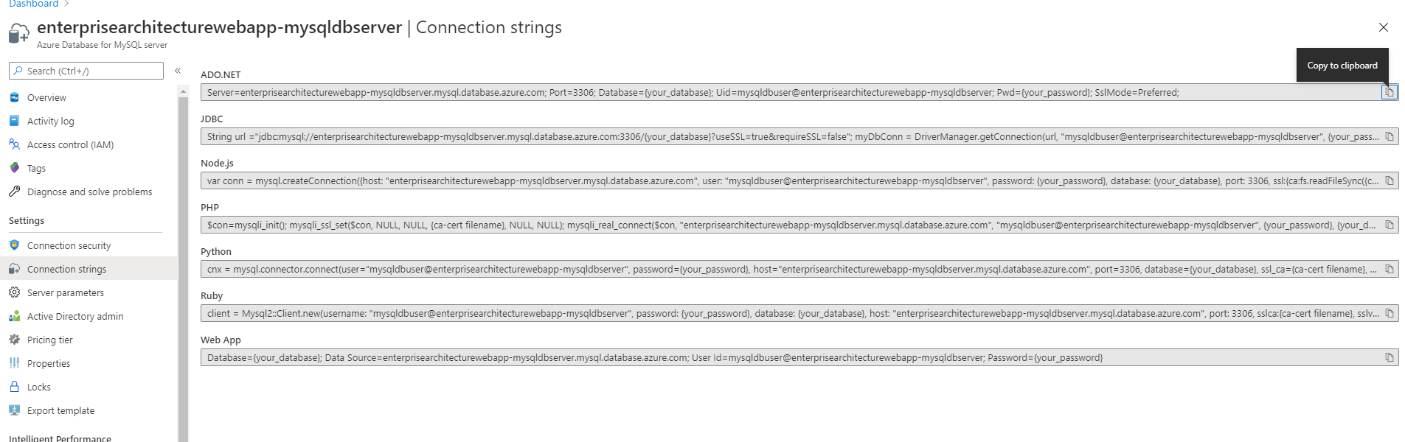

1. **Create a new Web App service phpMyAdmin extension.**

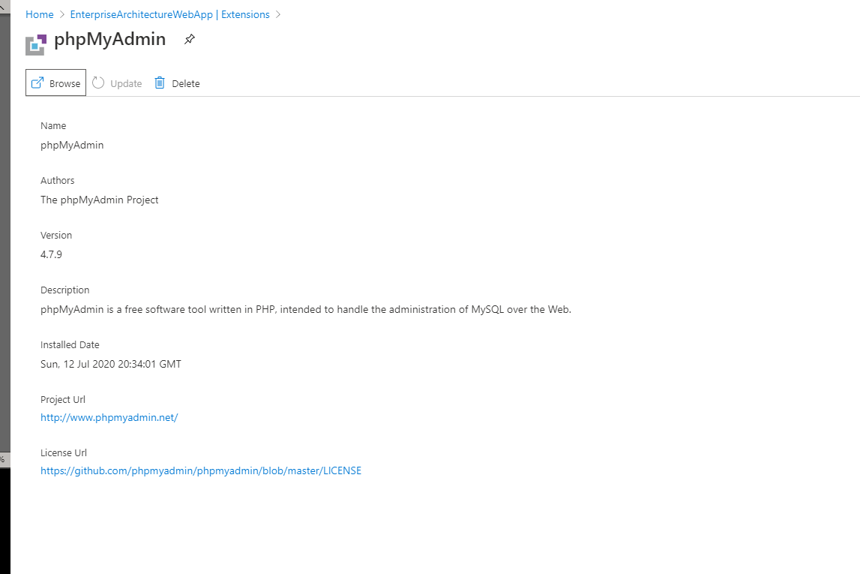

1. **Created PHP service and launched PHP my Admin**

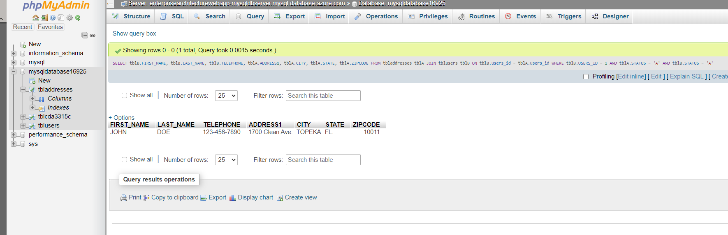

1. **Create Index.php frontend**

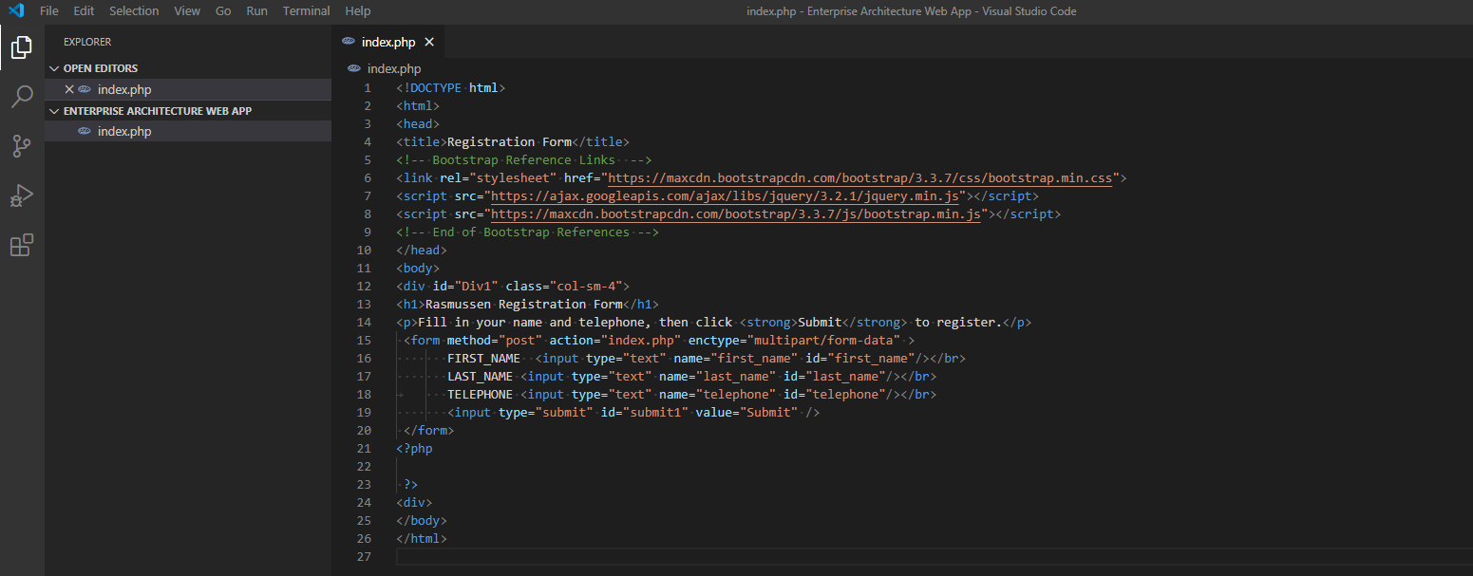

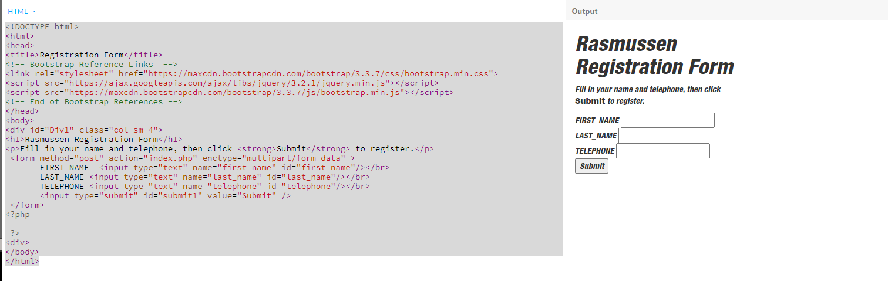

1. **Login to the new phpMyAdmin web app.**

**I had some issues with the inline CSS, so I had to repair it to the best of my knowledge using bootstrap and raw CSS It is responsive now see below.**

**Issues from CSS:**

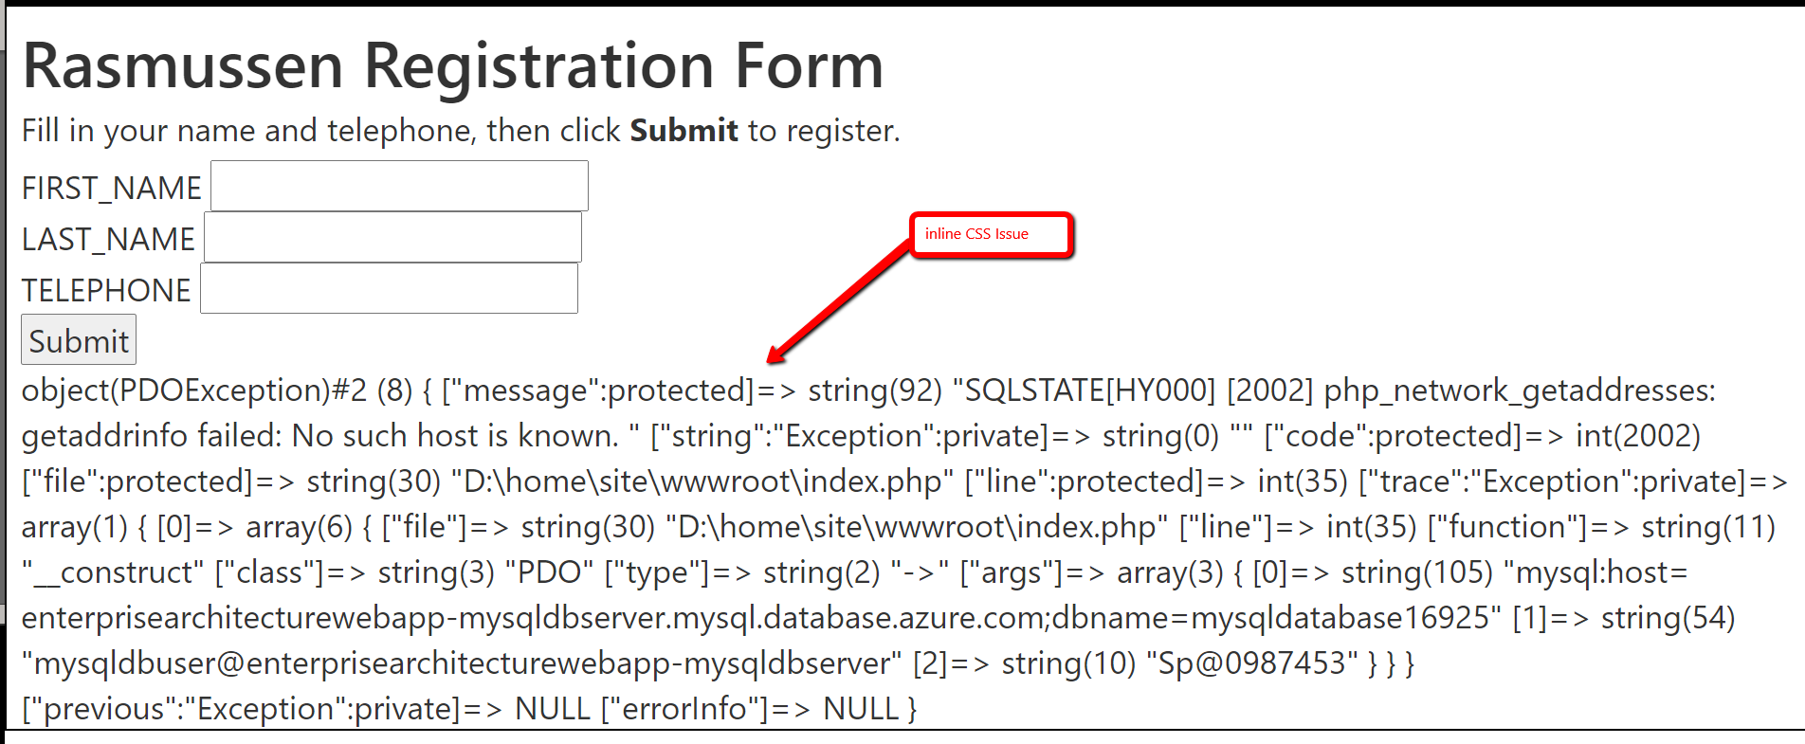

1. **Using FTP to load finished Web App:**

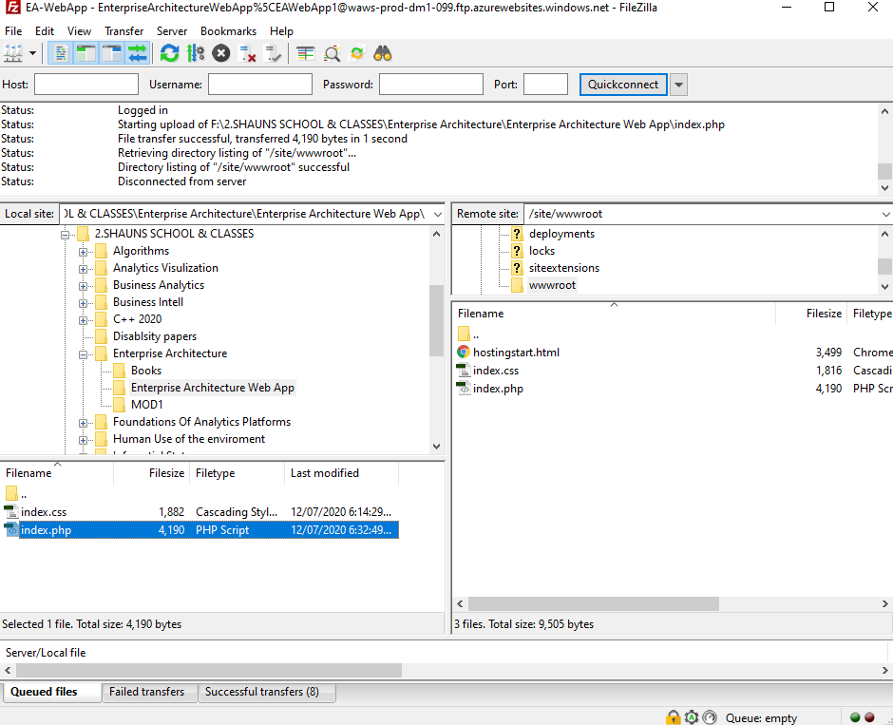

**10.Finished responsive Web App with 6 submit to DB styled by me:**

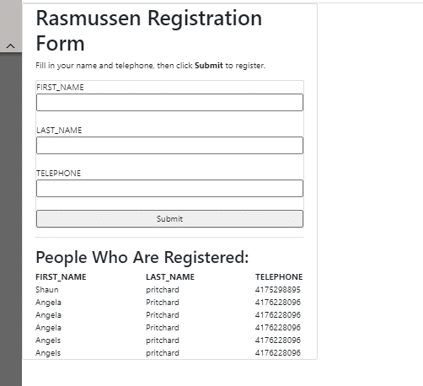

1. **Responsive version**

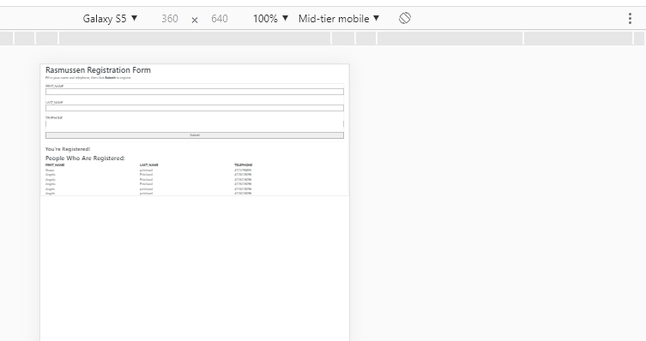

1. Here is with the original inline CSS style. It did not seem to scale correctly.

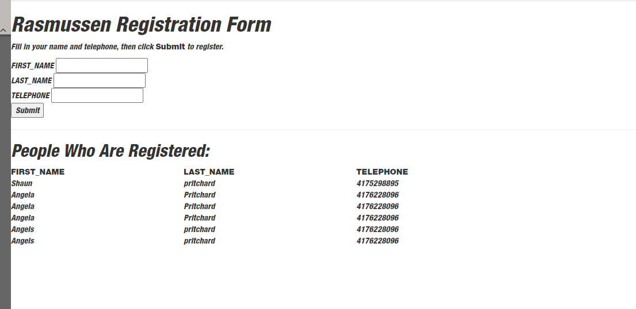

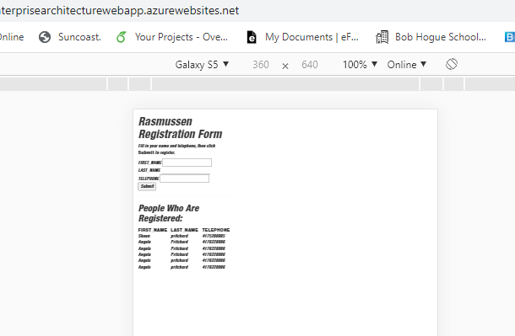

**Finished…**

**Lab- Module 2:**

1. **Updated style of user registration form centered column and made fully mobile responsive.**

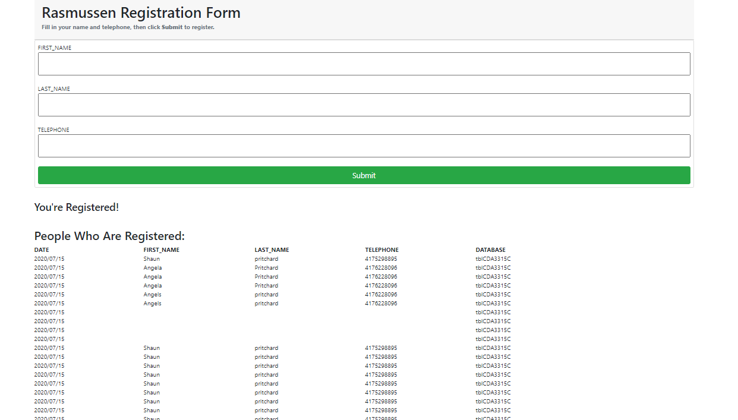

1. **Added 5th column to display the database table name of saved registered users**



1. **Added functionality to pull out all database table names programmatically using PHP and display them in the web Application.**

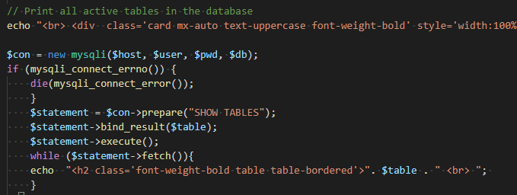

1. **Added delete functionality to remove a user row from the submission list.**

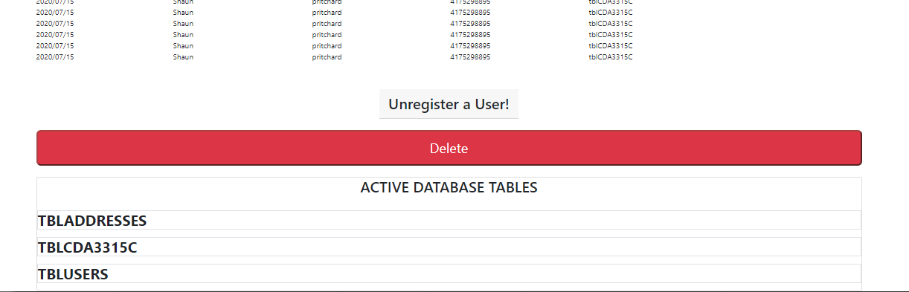

1. **Can delete users from submission list.**

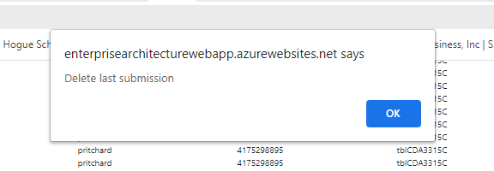

**Record with user Shaun:**



**Removed record of user Shaun:**



1. **Is mobile responsive and improved**

